Hunting and Gathering Progression

Australopithecus and Paranthropus genus:
Stone tool culture: Did not work stone
Communication: Could not speak. Likely to have communicated with grunts and gestures.

Hunting/Gathering: Women probably GATHERED roots and berries, fruits etc. They would have used digging sticks to get to roots. They probably ate insects and small creatures like mice which they caught.

Homo habilis:
Stone tool culture: Stone tools of Oldowan tool culture were not effective hunting tools but they had choppers which may have been used for digging up roots and the flakes could have been used to cut up animals
Communication: Could not speak. Likely to have communicated with grunts and gestures.

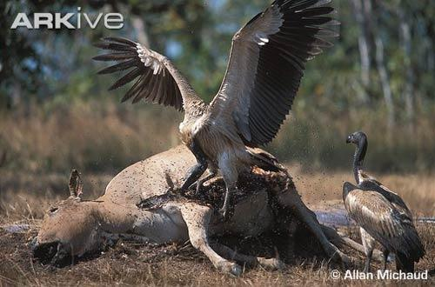
Hunting/Gathering: Women probably GATHERED roots and berries, fruits etc. They would have used digging sticks or choppers to get to roots. They probably ate insects and small creatures like mice which they caught the next step would have been to SCAVENGE by shoo away vultures from a carcass killed by one of the big predators. It is possible they were the first HUNTERS.
Once a taste for meat developed, hunting may have been only a thought away. The simplest form of hunting, a chase, does not require stone tools which would be evidenced today.

The chase: In a group the humans selected an order of runners. They then picked a target from a herd of reindeer that was at the edge of the herd so easy to cut off from the herd. The first runner got in behind the reindeer driving it away from the herd using sticks to wave at it and making loud noises (grunts). As the first runner tired the second runner took his place and continued chasing the deer then the third runner and forth runner etc until the deer fell from exhaustion. The hunters killed the deer by breaking its neck then proceeded to butcher it.

Homo erectus:
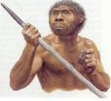
Stone tool culture: Stone tools of Acheulian tool culture were not effective hunting tools but they could have used the hand axes as diggers for roots and cleavers as knives to cut up animals
Other weapon advancement: They may have had wooden spears.
Communication: May have had limited vocal ability but not structured language.
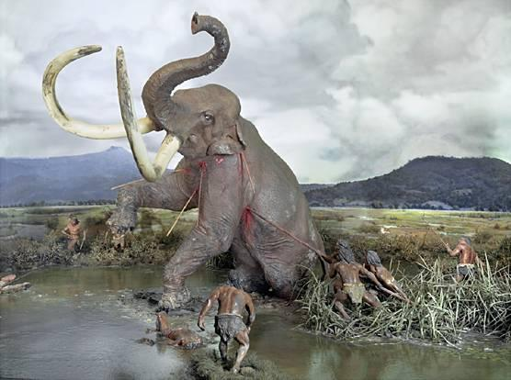
Hunting/Gathering: Women probably GATHERED roots and berries, fruits etc. They would have used digging sticks or hand axes to get to roots. They probably SCAVENGED and HUNTED meat. With the control of fire they could use this in hunts and their increased communication would make it easier to organise large groups of hunters for large co-operative hunts.

The co-operative group hunt: Bands of H. Erectus met together to co-operate for a hunt because the job was too big for a single band. They set fire to the grass, and drove large elephants in the herd into a bog where they got stuck and died. The bands of humans butchered the animals, even placing some legs of the elephants in a row as a bridge over the mud.

Homo Neanderthalensis:
Stone tool culture: Stone hunting weapons included spear tips attached to wooden spears and bolas (2 round stones strung together that trip animals when thrown and wrap around legs).
Other weapon advancement: They used fire to make fire hardened points on wooden spears.
Communication: May have had structured speech but not as great a range as modern humans.

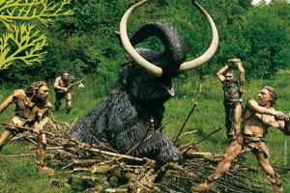
Hunting/Gathering: Women probably GATHERED roots and berries, fruits etc. They would have used digging sticks or stone diggers to get to roots. They HUNTED meat and probably still SCAVENGED. With advances in weapons the killing of larger beasts away from cliffs would have become possible and their increased communication would make it easier to organise large groups of hunters for large co-operative hunts.

The co-operative group hunt: A group of Neanderthals organised a group hunt where they surrounded a herd of horses then chased them over a cliff by scaring them with torches of fire and waving skins or spears at them. They then climbed down the cliff to butcher the animals.

Homo Sapiens:
Stone tool culture: Upper Palaeolithic tool culture fashioned a wide range of hunting tools such as stone spear tips attached to wooden spears, fish hooks and harpoons.
Other weapon advancement: They used fire to make fire hardened points on wooden spears.
They had throwing sticks for spears which allowed them to reach targets from further away by increasing throwing range).
Communication: Likely to have had structured speech/language

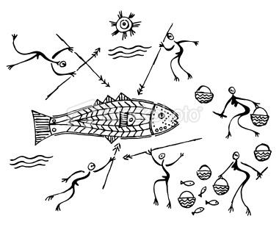
Hunting/Gathering: Women probably GATHERED roots and berries, fruits etc. They would have used digging sticks or stone diggers to get to roots. They HUNTED meat and possibly still SCAVENGED. With advances in such as fish hooks and harpoons, fish became an important food source. Increased communication would make it easier to organise large groups of hunters for large co-operative hunts.

The co-operative group hunt: Several tribes of H. Sapiens joined together for a mass hunt. They built large wooden surrounds by a ravine (a deep narrow valley or gorge in the earth's surface). in preparation. They worked in groups to drive a herd of one thousand bison into the ravine then closed the surround. In the ravine where the bison were trapped they killed them from a distance by throwing spears. The development of spear throwers allowed them to reach their target from greater distance away and therefore decreased the chance of being gored.
With hunting, humans learned to follow herds and to adopt their wandering way of life

The development of Domestication

Domestication of animals came before plants. The first domesticated animal was the wolf (breed over time into today’s dogs) about 13,000 years ago.
Domesticated  Animal | Wild Ancestor | Region of Origin | Date  (Years ago)
Dog | Wolf | many places? | 13 000
Goat | Bezoar goat | Iraq | 10 000
Sheep | Asiatic mouflon | Iran, Iraq, Levant | 11 000
Cattle | Aurochs | Southwest Asia | 8 500
Pig | Boar | Anatolia | 9 000
Domestic fowl | Red jungle fowl | Indus Valley | 4 000
Horse | Wild horse | Southern Ukraine | 6 000
Arabian camel | Wild camel | Southern Arabia | 5 000
Bactrian camel | Wild camel | Iran | 4 500
Llama | Guanaco | Andean plateau | 6 000
Water buffalo | Indian wild buffalo | Indus Valley | 4 500
Ass | Wild ass | Northeast Africa | 5 500

The development of agriculture:
- Farming began in different parts of the world at different times:
  - Earliest evidence is found in the so-called ‘fertile crescent’ running from Egypt to the Persian Gulf about 10 000 years ago.
  - By about 7 000 years ago, agriculture became established in China.
  - This was followed by Mesoamerica (Guatemala, Honduras and southern Mexico) about 5 000 years ago.

Draw a timeline showing progression from gathering to inclusion of scavenging to hunting then domestication and agriculture.

